**Foundations of Algebra**

**Summer Math Packet**

This is ________________________________________________’s summer math practice.

The purpose of the summer math packet is to maintain your math skills so you can “hit the ground running” at the start of high school.

When: The attached problems are due on the first day of school, September 2019. For best results, make a plan and spread out the work over the summer months.

Suggestion: Do one section every week. You’ll be done well before the summer is over.

Choice: Please complete 5 of the 7 sections. You do not need to complete all 7.

**SHOW ALL WORK:** To earn credit for your summer math packet, you must show all work.

Why show work?

* + To help you retain the skills in the Summer
  + To help your teacher see how best to work with you in the Fall
  + So you will earn credit for your summer work

Use a paper copy of this packet to show your work.

Use a digital copy of this packet to click on the links for online resources.

**Resources:** To help you complete the summer math packet, you may use the online resources shown throughout the packet. For some problems, you may need to search for other videos related to the ones you’ll find at the links given in the packet.

**Section 1: Problem-solving: Saving Money**

**Section 2: Recording Contract: Deal #1 or Deal #2?**

**Section 3: Numbers and Operations**

**Section 4: Fractions/Decimals/Percents**

**Section 5: Graphing Lines**

**Section 6: Ratio and proportion**

**Section 7: Area and perimeter**

**Section 1: Problem-solving: Saving Money**

**SHOW ALL WORK**

Resources:

<https://www.khanacademy.org/math/algebra/linear-word-problems/modal/v/graphing-linear-functions-1>

Suppose Eli gets a great job and saves $200 per week.

Before he got the job his bank account had $325 in it.

At the end of each week, Eli adds $200 to his bank account.

Eli wants to save $3000.

1. Complete this table of the two variables money (M) and weeks (W).

You choose the numbers for W. Then find M for each W you chose.

|  |  |
| --- | --- |
| W = weeks since Eli started his new job | M= amount of money Eli has in the bank |
| 0 | 325 |
| 1 |  |
| 2 |  |
|  |  |
|  |  |
|  |  |
|  |  |
|  |  |
|  |  |
|  |  |
|  |  |

2. Question: After how many weeks will the amount in the bank be $3000 or more?

Use any method to answer this question.

On the next page…

show your work and explain in words how you know your answer is correct>>>>>>

Use this page to show your work for Section 1.

Show your work AND explain in words how you know your answer is correct.

“After how many weeks will the amount in the bank be $3000 or more?”

**Section 2:**



**Recording Contract: Deal #1 or Deal #2?**

Nice work.

Your group was just offered two recording contracts.

Call them Deal #1 and Deal #2:

**Deal #1:** You earn $1.00 for each download,

plus you receive a $60,000 signing bonus.

**Deal #2:** You earn $3.00 for each download,

but your signing bonus is only $10,000.

1. Which deal would you accept? Why?
2. Complete the table below:

|  |  |  |
| --- | --- | --- |
| *x = number of*  *downloads* |  |  |
| 0 | $60,000 | $10,000 |
| 10,000 | $70,000 | $40,000 |
| 20,000 |  |  |
| 30,000 |  |  |
| 40,000 |  |  |
| 50,000 |  |  |

**Section 2 (continued):**



**Recording Contract: Deal #1 or Deal #2?**

1. If you took Deal #2, how many downloads would you need to sell to earn the ***same*** income as you would earn with Deal #1?

___________downloads

*How do you know?*

*Explain how you know in the space below.*

**Section 3: Numbers and Operations**

**SHOW ALL WORK**

Do the problems in section 3 & 4 *WITHOUT A CALCULATOR*.

You will need to do these types problems without a calculator on quizzes in high school.

**Online resources:**

Addition of Integers –

* <http://www.mathgoodies.com/lessons/vol5/addition.html>
* <http://www.youtube.com/watch?v=204uFu0DRWE>

Subtraction of Integers –

* <http://www.mathgoodies.com/lessons/vol5/subtraction.html>

Multiplication and division of integers

* <http://www.mgccc.edu/learning_lab/math/multdiv.html>

Square root -

* <https://www.khanacademy.org/math/arithmetic/exponents-radicals/radical-radicals/v/understanding-square-roots>

**NO CALCULATOR FOR THIS SECTION**

1) For each problem, add the two integers:

a) – 1 + 3 a) _________________

b) 7 + (– 10) b) _________________

c) – 2 + ( – 5) c) _________________

2) Complete the following subtraction problems:

a) 2 – ( – 5) a) _________________

b) – 5 – 7 b) _________________

c) 12 – 8 c) _________________

**Section 3: Numbers and Operations (continued)**

**NO CALCULATOR FOR THIS SECTION**

3) Multiplication:

1. =
2. =
3. =
4. =

4) Division:

a) =

b)

c)

d)

e)

5) Which expression has the larger value, or 32? How do you know?

**Section 4: Fractions/Decimals/Percents**

**SHOW ALL WORK REDUCE FRACTIONS**

Do the problems in section 3 & 4 *WITHOUT A CALCULATOR*.

You will need to do these types problems without a calculator on quizzes in high school.

**Web resources:**

Vocabulary - information about underlined words in the problems can be found at:

* <http://www.math.com/school/glossary/glossindex.html>

Fractions and mixed numbers (add, subtract, multiply, divide) –

* <https://www.khanacademy.org/math/arithmetic/fractions>

Percent problems - <http://www.mathgoodies.com/lessons/percent/sale_price.html>

**NO CALCULATOR FOR THIS SECTION REDUCE FRACTIONS**

1) Write 2.75 as a ratio of two integers. Write the ratio as a fraction.

2) Multiply. Show your work. ­­­­­­­­­­­­­­­­ =

3) Write the reciprocal of You “flip” the fraction to find the reciprocal.

4) Divide. Show your work.

5) Divide. Show your work. = ____________________

**­­­­**

**Section 4: Fractions/Decimals/Percents (continued)**

**NO CALCULATOR FOR THIS SECTION REDUCE FRACTIONS**

5) Subtract. Show your work. =

6) Subtract. Show your work. =

7) Add. Show your work. 5.01 + 0.43 + 0.40

8) A jacket originally sold for $45. This week it is on sale for 20% off.

What is the discount and what is the sale price? Show your work.

Discount___________________________

Sale price__________________________

9) A student answered 44 questions correctly on a test with 55 questions. What percent of the test was answered correctly? Show your work.

Percent correct __________________________________

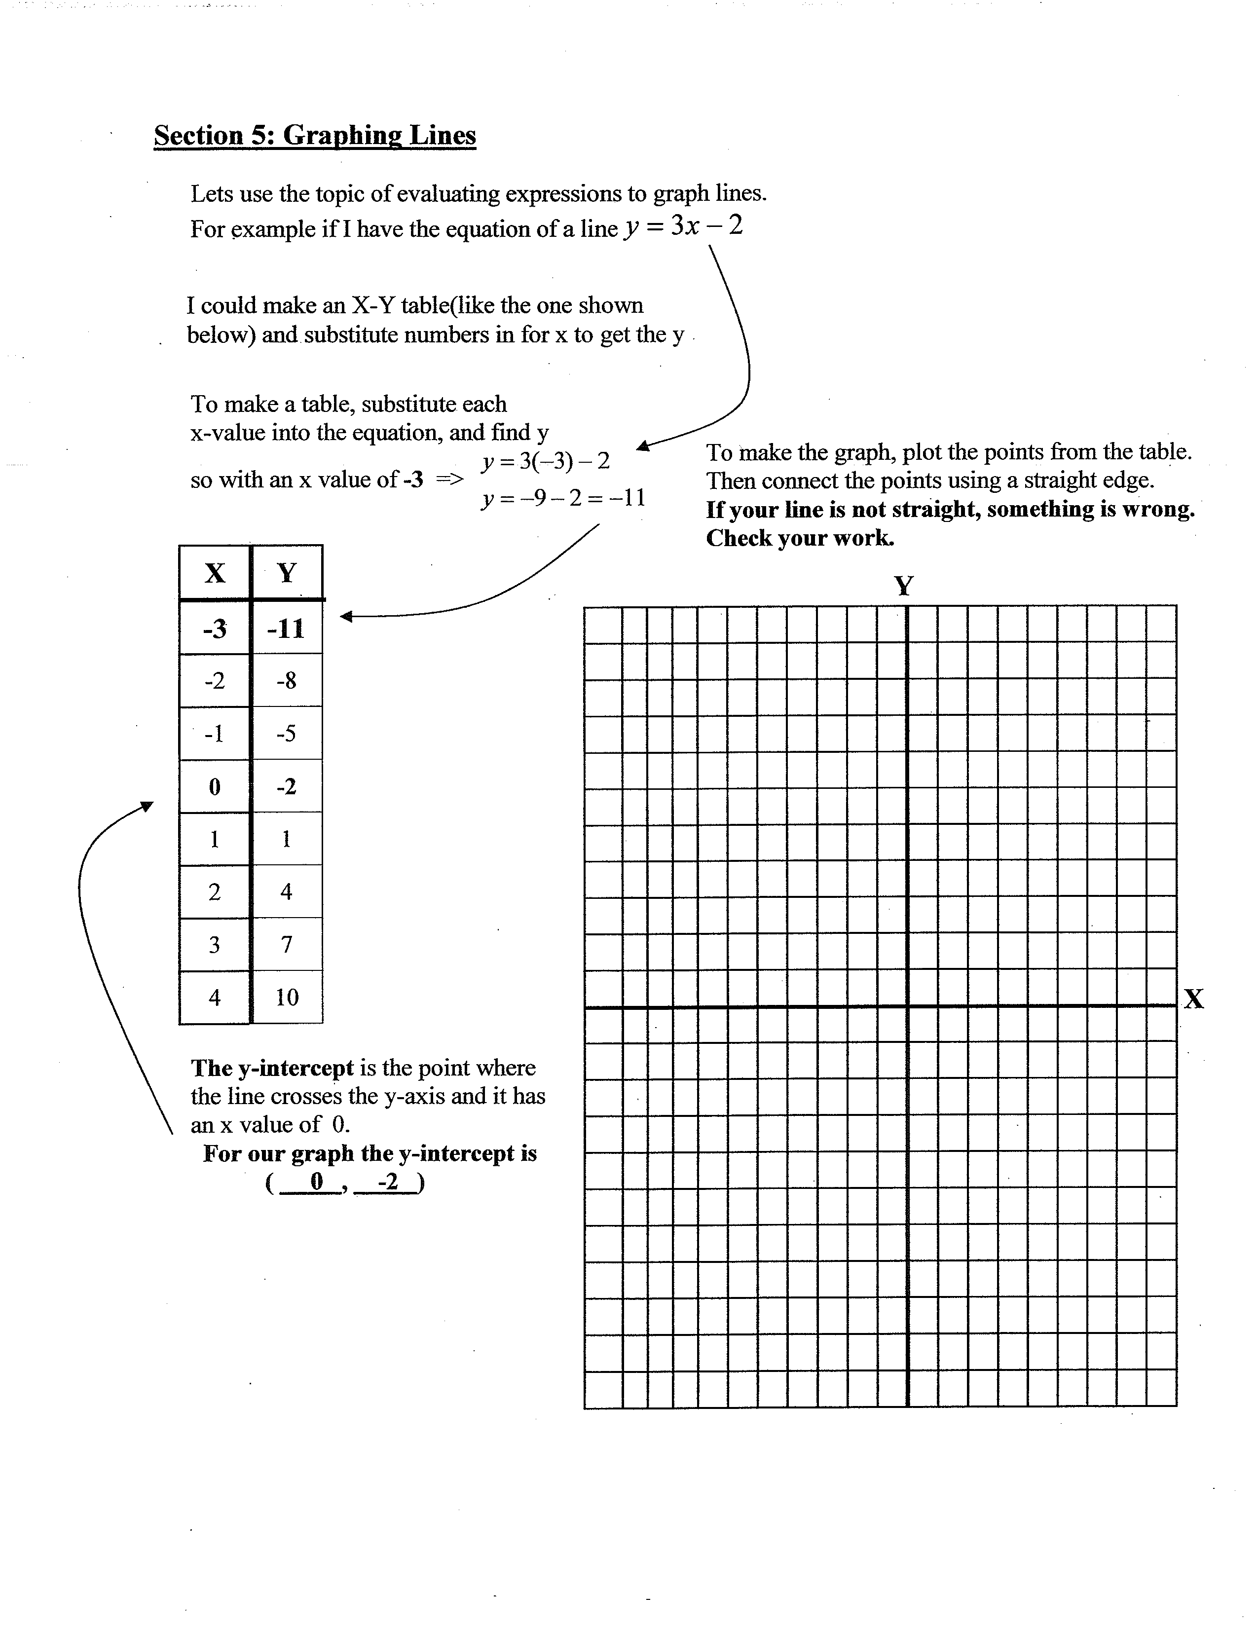

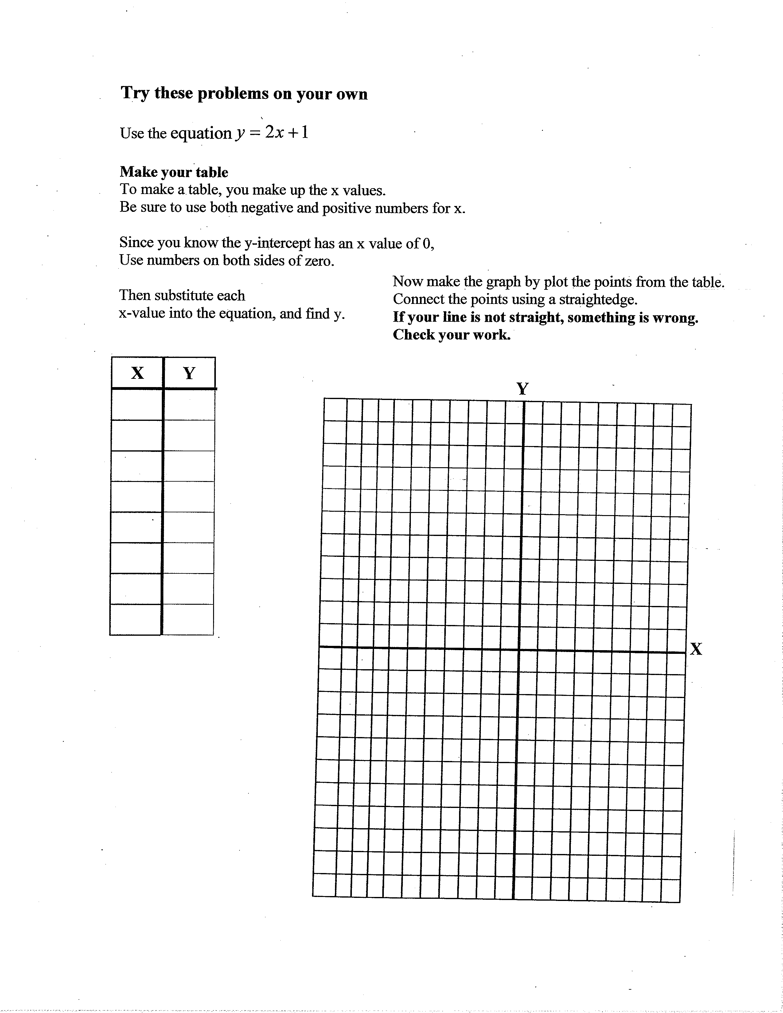

**Section 6: Ratio and proportion**

**SHOW ALL WORK**

**Web resources**

[**http://www.khanacademy.org/math/arithmetic/rates-and-ratios/ratios_and_proportions**](http://www.khanacademy.org/math/arithmetic/rates-and-ratios/ratios_and_proportions)

**SHOW ALL WORK ON THIS PAGE**

1. Reduce the fraction to lowest terms:

1. A. Write the ratio of girls to boys in a class with 12 girls and 15 boys.

Reduce the ratio to lowest terms.

B. Estimate the number of girls in the school if there are a total of 850 boys in the school.

(Assume the class in #2A is representative of all classes in the school.)

1. The equation below is called a proportion because it shows that two ratios are equal.

To solve a proportion you can “cross-multiply.”

Solve for *d*:

**Section 6: Ratio and proportion (continued)**

1. Solve for *g*: **SHOW ALL WORK**

1. For #5, a 3.5 pound package of hamburger costs $11.20.
2. What is the cost of two pounds of hamburger? Use any method. **SHOW ALL WORK**
3. What is the ratio of dollars to pounds? Write the ratio as a fraction.
4. Write a proportion that you could have used to answer question #5A.

Start with the ratio of dollars to pounds.

6. The scale on a map indicates 1 inch = 150 miles. The distance from Philadelphia to Miami is 1200 miles. On the map, how far apart are Philadelphia and Miami?

7. A recipe calls for 3 cups of sugar for every 4 pounds of fruit. How many cups of sugar are required for 10 pounds of fruit?

**Section 7: Area and perimeter**

**Web resources**

Area and perimeter of rectangles

<http://www.mathgoodies.com/lessons/vol1/area_rectangle.html>

Area of triangles

<http://www.mathgoodies.com/lessons/vol1/area_triangle.html>

Perimeter

<http://www.mathgoodies.com/lessons/vol1/perimeter.html>

**SHOW ALL WORK ON THIS PAGE**

**ALL ANSWERS MUST INCLUDE UNITS (feet, square feet, etc)**

1. The first floor of a one-story house is in the shape of a rectangle. The house is 25 feet wide and 60 feet from front to back.
   1. Draw a sketch of the house (rectangle). Label the width and length.
   2. What is the area of the first floor of the house?

(area of a rectangle = length times width)

1. A triangle has a base of 10 inches and a height of 25 inches.
   1. Draw a sketch of the triangle. Label the base and the height.
   2. What is the area of the triangle?

(area of a triangle = base times height, divided by 2)

**Section 7: Area and perimeter (continued)**

**SHOW ALL WORK ON THIS PAGE**

**ALL ANSWERS MUST INCLUDE UNITS (feet, square feet, etc)**

1. A patio is a rectangle 12 feet wide and 16 feet long.

The patio is completely surrounded by a fence.

(The length of the fence is called the perimeter of the rectangle.)

How long is the fence?

1. A square has an area of 64 square feet. Draw a sketch of the square.
2. What is the length of each side of the square?
3. What is the perimeter of the square?
4. The Emerald City is shaped like a rectangle.

The length of the rectangular city is 6 miles greater than the width.

If the border of the city (the perimeter of the rectangle) is 68 miles…

* 1. What is the width?

STRATEGY: Guess a width and check to see if the perimeter would be 68. Then guess again…

* 1. What is the length?
  2. What is the area of the city?